This Black Rock NRZ 2018 Annual Report is submitted in accordance with the Black Rock NRZ Bylaws Section 6.08.
- Executive Overview and 10-Year Summary
After a decade long effort, in 2018 the Black Rock NRZ began to segue into a new phase.
The NRZ’s keystone goal for the revitalization of Black Rock was to establish a Village District along Fairfield Avenue. In 2011 presentations were made to the Director of the Office of Planning and Economic Development (OPED) and the Mayor to develop this Village District. The City provided funding and personnel to commission a study. The study results served as the basis for OPED’s design of a Commercial Village District Overlay Zone which was incorporated into the Zoning Regulations.
In addition, State grants have funded two major projects, a gateway from the Town of Fairfield into Black Rock at the Village District and a pedestrian bridge and associated accesses from Black Rock to the newly built Fairfield Metro railroad station. The gateway project will begin construction in 2019 and the pedestrian bridge is nearing the completion of its design stage.
As part of the NRZ activities both grammar schools in Black Rock have been improved; one by expansion to seventh and eighth grade and the second by a completely new building.
Parks have been added and upgraded; a new “pocket park” was built as part of an improvement to an intersection, a major upgrade was done to 2 existing parks, and a brand new baseball field has been constructed.
The NRZ was solely responsible for working with a developer to revitalize an historic house in the historic district. The developer wanted to raze the house and build condominiums. NRZ members negotiated with the developer, worked with him on a plan that would restore the house and supported his new plans before zoning boards. The agreement between the developer and the NRZ was written in the zoning boards approvals.
The Black Rock Art Guild (BRAG) was established and has been prominent with art shows and poetry readings in Black Rock venues and in nearby areas of Bridgeport and Fairfield.
Bridgeport City and State officials have been active in helping Black Rock’s revitalization. In addition to acquiring funding and overseeing the two projects described above, one City Council Member (Peter Spain) has been leading the effort to revitalize the long neglected Capozzi Park located at the entrance to Saint Mary’s Park. Another City Council Member (Christina Smith) is taking the lead as a co-chairperson of the committee amending the Strategic Plan. The Black Rock State Representative (Stephen Stafstrom) enlisted the support of the Bridgeport legislative delegation to pass a statute that requires Connecticut municipalities to indemnify NRZs. This is important in protecting NRZ members as they deal with certain issues such as land use and development projects.
Over 80% of the Black Rock Strategic Plan activities have been completed. After a decade of accomplishments, it’s time for the NRZ and the community to reevaluate the Strategic Plan to decide how to incorporate the successes achieved into an even greater step forward in the revitalization of Black Rock.
A subcommittee of the Board of Directors and members of the community is being formed to amend the Strategic Plan. Among the potential areas that may be addressed are:
- There is need for expanded parking areas in Black Rock. This is a result of the growth and popularity of restaurants in the Village District.
- An effort to include members of the community from Census Tract 702 into participation in the NRZ and the planning effort.
- Extension of a village-district like area into the Census Tract 702 part of Fairfield Avenue where new restaurants and automobile showrooms of American and international cars are displayed. Buildings in this area are interesting structures with ground level venues that can be incorporated into the Village District. Two outstanding venues are car restoration businesses with very enticing showrooms.
- A major thrust in organizing the businesses and implementing facade improvements.
- Organization
The 2018 Members of the Board of Directors are:

David Barbour | Karyn Leito
Pierre Belizaire | Gerry Manning
Phil Blagys | Michelle Margo
Scott Burns | Lazaros Papanikolaou
Robert Foley | Linda Simard
Courtney Hartl | John Soltis
Peter Holecz | Kate Spain
Joseph Ianniello | L. Kraig Steffen
John Marshall Lee | John Weldon
Joe Larcheveque | Bruce Williams
EX Officio Members | Office
Christina Smith | 130th District City Council Member
Peter Spain | 130th District City Council Member

The 2018 Executive Committee consisted of the following elected members:
President: | Scott Burns
Vice President: | David Barbour
Treasurer: | John Marshall Lee
Secretary: | Joe Larcheveque
Elected Member: | Gerry Manning
Elected Member: | Joseph Ianniello

- Committees
John Marshall Lee (chairman) and John Soltis served on the Nominating Standing Committee.
In addition to the Nominating Standing Committee, the bylaws define six Standing Committees that drive the Strategic Plan implementation process. The Standing Committees and their chairpersons are:
Standing Committee | Name | Chairperson
1 | Business & Economic Development | John Weldon
2 | Education | Open
3 | Arts, Entertainment & Culture | Bruce Williams
4 | Land Use, Development, & Historic Preservation | John Weldon
5 | Outreach and Communications | Open
6 | Quality of Life, Environment, & Public Safety | Phil Blagys, Kraig Steffen
Design Committee: This ad hoc committee was established to deal with development efforts. Personnel with special skills serve on this committee and the committee’s importance will increase as the NRZ evolves to the next phase of Black Rock development and revitalization. It is expected to merge with Standing Committee 4 and possibly Standing Committee 1.
Strategic Plan Update Committee: This is an ad hoc committee. Christina Smith and Vanessa Liles will co-chair this committee to amend the Strategic Plan. Vanessa is a member of the West Side NRZ. They will work to get more representation from residents and businesses within Census Tract 702.
- OPERATIONS
There were 4 regular and 5 special meetings of the Board of Directors in 2018. There were also meetings of the Executive Committee and the NRZ Standing Committees.
As part of the bylaws the NRZ supports other Black Rock groups. In 2018 the NRZ worked with the following groups:
- Ash Creek Conservation Association (ACCA)
- Black Rock Art Guild (BRAG)
- Black Rock Business Association (BRBA)
- Black Rock Community Council (BRCC)
- Black Rock Farmers Market. The NRZ served as fiduciary for the market and provided funding. The Farmers Market was unable to continue in 2019 because of economic issues.
- Black Rock Garden Club (BRGC)
- Burroughs Community Center (BCC)
- Friends of the Bridgeport Public Library (FBPL)
The Black Rock NRZ’s John Marshall Lee and the West Side NRZ’s Frank Borres established the Bridgeport NRZ Leadership Committee (BNLC) that consists of the leaders in each of the eight Bridgeport NRZs. Joseph Ianniello, a member of the Black Rock NRZ Executive Committee, was Secretary of the BNLC in 2018.
The Black Rock NRZ, Inc. worked with members of both the City of Bridgeport’s administration and the State Legislature, including the following people in 2018:
- Steven Stafstrom, 129th (Black Rock) District State Representative
- Peter Spain, 130th City Council Member and a board member
- Christina Smith, 130th City Council Member and a board member
- Alma Maya, OPED Neighborhood Outreach Coordinator
- Angie Staltaro, a retired member of the disbanded Neighborhood Revitalization Department and now a consultant working with Alma Maya
- Administrative Accomplishments
The Black Rock NRZ updated their Bylaws in 2018. A summary of the changes made is:
- Ex-Officio Directors: The bylaws specified an ex officio member from a City department that was disbanded. In the updated bylaws this position will be an Executive Committee appointment limited to a person with special skills and experience needed by the NRZ, or from a government agency or another Black Rock organization.
- Quorum: The wording of the bylaws was changed to clarify poor wording and ambiguities.
- Term Limits: Term limits were eliminated.
- Executive Committee: The number of at large Executive Committee members was increased from 2 to 3.
NRZ Indemnification: The Black Rock NRZ had worked, unsuccessfully for several years to get the NRZ indemnified. A champion was found in Connecticut’s 129th district State Representative Steven Stafstrom who led the charge in Connecticut’s House of Representatives and enlisted the aid of the Bridgeport Senate delegation to amend the State statute that defines NRZs. The amendment officially went into effect in July. The statue now requires all Connecticut municipalities to indemnify their NRZs.
NRZ Training: The City hired a consultant who develop a Bridgeport NRZ Academy. Four members of the Black Rock NRZ attended the Academy’s workshop for NRZ officers and key personnel held on January 12, 2019.
- Treasurer’s Report
The Black Rock NRZ, Inc. received their designation as a 501 (c) 3 organization in 2011 to facilitate fundraising.
{Report to be supplied by Treasurer John Marshall Lee}.
- Highlights of Activities

Standing Committee 1: Business and Economic Development:
Major projects in 2018 were:
- The Pedestrian Bridge from Black Rock to the Fairfield Metro Train Station
- Black Rock Commercial Village District Gateway Improvements
- Mixed use development with ground floor retail venues available and upper level apartments at the corner of Fairfield Avenue and Fox Street.
- Mixed use renovation of the Bank Building at the corner of Fairfield Avenue and Brewster Street; ground floor retail venues and upper floor apartments.

Although c and d are not NRZ projects they are excellent developments and will benefit from the Fox Street Bridge project, the Commercial Village District Gateway Improvements, and Commercial Village District Overlay regulations since these improvement enhance the desirability of the Black Rock area for housing and developments.
Each of these projects is described below.
- Pedestrian Bridge — Black Rock to Fairfield Metro Train Station:
In 2015, Bridgeport secured $3.8 million in Connecticut Department of Transportation funds to build a pedestrian bridge in Black Rock over Ash Creek to the Fairfield Metro train station.
The 160-foot steel truss bridge will provide greater access for Black Rock residents to the train station. With a walkway width of 14 feet, the bridge will be a safe and convenient improvement to Bridgeport’s transit oriented development.
The project also includes improvements to Fox Street (where one end of the bridge will connect) in anticipation of the increase in pedestrian and bicycle activity from Fairfield Avenue to the bridge site. The work includes reconstruction of sidewalks and curbs, along with the planting of street trees, and with the potential to extend the existing bicycle route from Fairfield Avenue to the bridge.
In addition to the bridge structure, there will be improvements to the Creek trail. The 650 foot walkway extending Canfield Avenue creates a pedestrian greenway along current dead ends from Fox Street to Davidson Street. This will significantly increase the ¼ mile walkshed to the Fairfield Metro train station and create a scenic greenway along Ash Creek. The trail work will also eradicate existing invasive plant species and create upland meadow vegetation.
On the Bridgeport side of the bridge, there will be a gateway plaza constructed to connect to the bridge. On the Fairfield side, there will be work to help connect the wetlands walking trail and the train station.
The design is nearly complete and the bridge is expected to complete construction in late 2020 or early 2021.
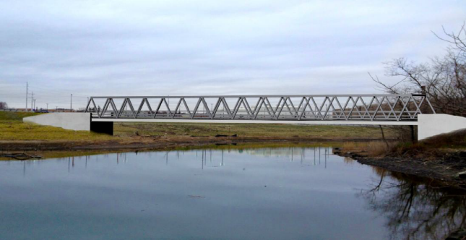
A rendition of the pedestrian bridge span over Ash Creek that will connect the Bridgeport neighborhood of Black Rock with the Fairfield Metro Rail Station in Fairfield.
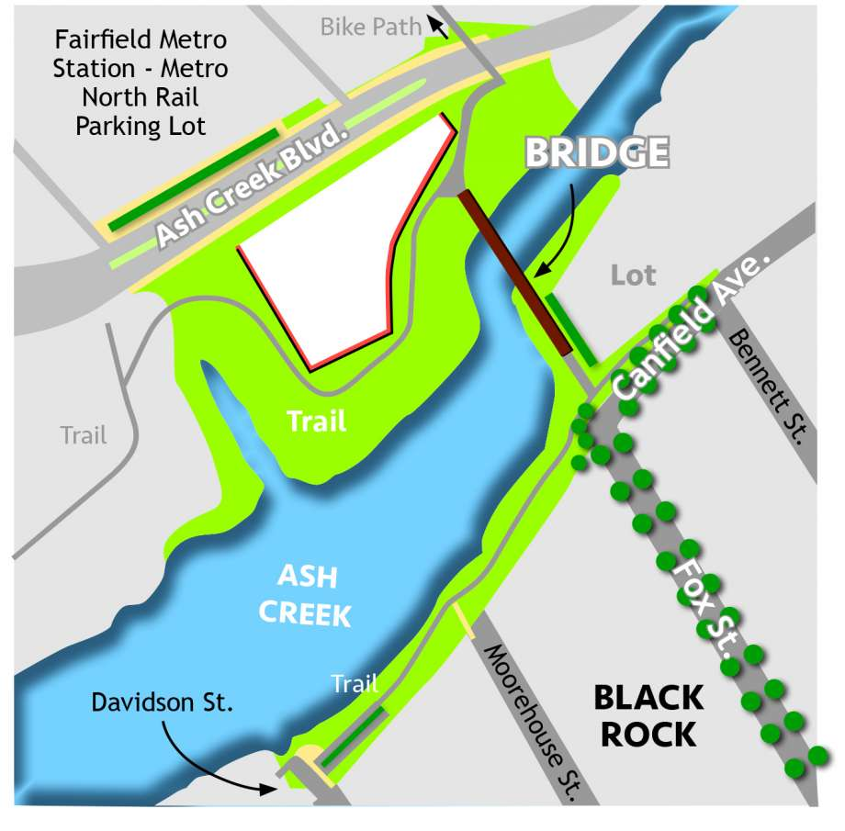
An aerial rendition of the pedestrian bridge showing the access via existing city streets and a walking trail along Ash Creek.

- Black Rock Commercial Village District Gateway Improvements:
Work continues on the $500,000 State grant to improve the section of Black Rock along Fairfield Avenue from the Fairfield Town Line to Brewster Street. The Brewster Street and Fairfield Avenue intersection is considered the center of the Black Rock Commercial Village District.
The Black Rock Business District Gateway Improvements consist of traffic calming strategies to improve the safety for pedestrians, bicyclists, and motor vehicles, while creating aesthetic infrastructure improvements to the streetscape. Along with sidewalk and planting improvements, focal design features include integrated stormwater bioswales, pervious parking stalls, stamped concrete sidewalks, large thermo/epoxy graphics in the roadway that are representative of the neighborhood character and a treatment for an existing historic mile marker.
Attractive corner "bump-outs" will provide a traffic calming, pedestrian-safe area on each of the four curb corners on Fairfield Avenue at Brewster Street. A bump-out is an 8-foot projection at crossways into the avenue that enables a motorist to see pedestrians waiting to cross the street. This improves safety since pedestrians have a shorter crossing distance. Also, a narrowing of the roadway should slow down traffic.
The project is in the design phase; construction should begin in the spring of 2018.
- Mixed Use Development at Fairfield Avenue and Fox Street:
A private developer has razed multi-family dwellings which previously occupied space at the northwest corner of Fairfield Avenue and Fox Street. In their place that developer has begun construction of a mixed-use building to have ground floor retail and second floor residential units. The building is intended to capitalize on the aforementioned pedestrian bridge connecting Black Rock to Fairfield Metro Train at the foot of Fox Street.
- Black Rock Bank and Trust Renovation:

This summary was contributed by NRZ Executive Committee member Phil Blagys, head of the BRCC History Committee.
The Black Rock Bank & Trust structure at the corner of Fairfield Avenue and Brewster Street is being renovated and expanded by a privately funded developer to include 15 market-rate apartments and 1550 square feet of commercial space on the first floor.

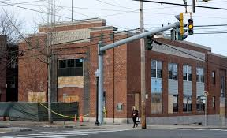
The Black Rock Bank and Trust Company under Renovation

Standing Committee 2 Education:
With the $13 million addition expanding Black Rock Elementary School to include classes for seventh and eighth grades completed in 2015, and the tear down of Longfellow School and building of the $51 million Geraldine Claytor Magnet Academy (GCMA) completed in 2018, the tasks of this Standing Committee are complete.

Standing Committee 3: Arts, Entertainment, and Culture:
The goal of the Arts, Entertainment, and Culture Committee is to distinguish Black Rock as a recognizable center for arts, entertainment, and culture.
Bruce Williams, Chairman of this Standing Committee, works closely with the Black Rock Art Guild (BRAG).
In 2019 the Black Rock NRZ will continue to support this effort.

Standing Committee 4: Land Use, Development, & Historic Preservation:
It is anticipated that this Standing Committee and the Design Review Committee will merge in 2019.
Design Review Committee: This ad hoc committee was established in 2016 to work mainly with Standing Committee 4 (Land Use, Development, & Historic Preservation). It is chaired by Vice President David Barbour.
The group includes members with expertise in architecture, landscape architecture, art, graphic design, and Black Rock history. In the interest of maintaining design quality in the neighborhood, the committee reviews proposed commercial developments, private and public. The focus is the evaluation of proposed designs’ aesthetic compatibility with the neighborhood. When aesthetic and/or design deficiencies are identified, the committee makes recommendations for improvements. The group also reviews petitions to the zoning boards to ensure that proposed projects maintain the quality compatible with the neighborhood. In 2019 an effort will be made to closely tie this committee with OPED.

Standing Committee 5: Outreach and Communications:
The main function of this committee is to inform the Black Rock community about the NRZ, our organization and activities, and to encourage their involvement.
The NRZ has a website providing information to the community and can be accessed at: https://blackrocknrzbpt.wordpress.com/.

Standing Committee 6: Quality of Life, Environment, & Public Safety:
Quality of Life: Quality of life tasks are distributed among other Standing Committees.
Environmental Tasks: The NRZ Environmental tasks coincide with the efforts and mission of the Ash Creek Conservation Association (ACCA).
NRZ Board Member Dr. Kraig Steffen is also Vice President of the ACCA and liaises with environmental issues that are part of Standing Committee 6 tasks.
Public Safety: The BRCC Public Safety Committee is chaired by Phil Blagys who sits on the boards of both the Black Rock Community Council (BRCC) and the Black Rock NRZ.
The BRCC Public Safety Council works to promote the safety and security of the community by integrating the efforts of residents with the Bridgeport Police Department and elected officials. It consists of neighbors (about 300 households) from all areas of Black Rock working together in a variety of roles to enhance the quality of life that Black Rock has always enjoyed. It is organized like a block watch with Area Coordinators, Street Captains, and Block Watch Members. Crime issues are vetted through this committee for accuracy.
The Safety Committee receives, summarizes, and monitors crime statistics from the Bridgeport Police Department. This summary is used to alert Black Rock residents to crime trends so that they can take action to improve the security of their property and be alert to watch for and report crimes.
BRCC Black Rock 375 Celebration:
The Black Rock Community Council is celebrating Black Rock’s 375th anniversary. There will be many events throughout 2019 to gratefully acknowledge the people, groups and moments that formed, inspired and enriched the history and community.
The mission of the Black Rock 375th Anniversary Committee is to share and celebrate the rich history and heritage of our community. This history spans nearly four centuries beginning with our colonial settlement and including our pivotal role in the War for Independence, our growth as a major trading and shipbuilding center, our transition to a thriving community linked to the growth of Bridgeport as an important industrial center and the development in the post-industrial years of a vibrant and close-knit community uniquely positioned to meet the challenges of the 21st century.
This anniversary will include events intended to promote this history. The committee will plan special 375th Anniversary exhibits, talks and presentations as well as walking tours and a special edition of the Black Rock Day Parade. Additionally, it will organize plaque dedications including the Goody Knapp Dedication, create a community time capsule and organize community celebrations including a final dinner dance. Furthermore, this anniversary planning will promote educational programs, develop a special anniversary street banner program and a virtual walking through history tour, design anniversary apparel, print a special anniversary calendar and plan any other events or programs consistent with our stated mission.
- NRZ Strategic Plan Goals
The Strategic Plan, in total, consists of 36 recommendations, which are summarized on Page 33 of the plan as tasks with detailed explanations on the pages immediately following. These 36 recommendations/tasks focus on key themes that came up repeatedly during the Planning Committee discussions, including: Environment and Open Space; Arts, Culture, and Entertainment; Zoning, Land Use, and Historic Preservation; Business and Economic Development; Design Review and Development Standards; Circulation, Access, Transportation and Parking; Quality of Life; and Education.
The 36 task summary is Table A-1 in Appendix A of this document.
- Related Tasks Completed
Table A-2 in Appendix A lists the detailed status of all tasks and summarizes the status in categories as complete, in-process, on-going, and not applicable.
The Strategic Plan Tasks Status Summary section in Appendix A lists 21 tasks as completed. They are tasks 1 through 3, 5 through 8, 10 through 14, 18, 21, 26, 30 through 34, and 36 in Tables A-1 and A-2.
These tables also list 6 tasks as not applicable and will not be addressed by the NRZ. The rationale for this is given in Appendix A’s Strategic Plan Tasks Status Summary section.
- Summary and Strategic Plan Update
Appendix A, Table A-1 is the Strategic Plan’s summary list of tasks. Table A-2 in the appendix provides a detailed status and accomplishment for each of the 36 tasks listed in the Strategic Plan.
The Strategic Plan Tasks Status Summary section in Appendix A states that 21 of the Strategic Plan tasks are completed and that 6 are not applicable. As explained in the appendix, the 6 classified as “Not Applicable” will not be addressed by the NRZ. Therefore 75% of the tasks are completed. Twenty-five percent (25%) are in-process or on-going.
In 2019 the NRZ will focus on the Commercial Village Overlay District (Village District) implementation with economic and cultural improvements, embedding historical themes, and extending improvements on Fairfield Avenue into Census Track 702 (Ellsworth Street to I95). This requires identifying and encouraging new development and rehabilitation of venues in keeping with the character of Black Rock to make it a pedestrian oriented and mixed-use district. The NRZ and the Black Rock community will need City, State, and possibly non-government grant support.
Also in 2019, the goal is to complete the Village District Gateway Improvements project and continue toward a 2021 completion of the Pedestrian Bridge from Fox Street to the Fairfield Metro Station. Both these projects are funded by State grants.
Some organizational initiatives may be necessary:
- A community design and development review board to work with zoning boards to help define and ensure compliance with Village District regulations and motifs.
- Strengthen the relationship with Black Rock organizations such as:
  - Ensuring the Black Rock Business Association (BRBA) takes a prominent role in the Village District implementation and maintenance
  - Forming a partnership with the Black Rock Community Council (BRCC) whose large membership with skills needed and long history of detailed knowledge and excellent reputation in Black Rock and Bridgeport would be an asset to the NRZ activities
- Increase awareness of the Black Rock historic significance to the City of Bridgeport. This would be a benefit to the City as well as to Black Rock.
Finally, an emerging problem is a lack of parking for access to Village District venues. The NRZ and community will have to work with the City in addressing this problem.

Respectively submitted,

_______________
Joseph W. Ianniello
Member of the Executive Committee

Approved by,

__________
Scott Burns
President

This report was approved by the Executive Committee on

Appendix A: Status of Strategic Plan Tasks

Table A-1 is from the Black Rock NRZ Strategic Plan page 33 and is a summary of the Strategic Plan tasks.

Table A-2 gives the status of each individual task in Table A-1.

Strategic Plan Statistics:

Task Status | Number of Tasks | Percent Complete
Completed | 21 | 58%
In-process | 5 | 14%
On-going* | 4 | 11%
Not Applicable** | 6 | 17%
Total | 36
*On-going tasks are activities that do not come to completion. For example Task 15 which states, “Identify, encourage, and support high-priority development” is open ended and continues. Similarly, Tasks 22, 23, and 28 are open ended and continue.
**Rationale for identifying tasks as Not Applicable is as follows:
Task Number | Description | Not Applicable Rationale
4 | Develop a Black Rock Waterfront Linear Park | St. Mary’s Park effectively satisfies this task
9 | Influence ordinance to deny zone changes in historic district | Requires a comprehensive look at an historic district plan
16 | Create incentives for sustainable development | A City effort
17 | Plan for the further development of Brewster Street | Could be a major effort after Village District is established
24 | Investigate potential for a neighborhood trolley route | Not enough venues at this time
35 | Identify additional funding for gaps in education | Board of Education function

There are 25 completed and on-going tasks. With 6 not applicable tasks there are a total of 30 actual tasks defined by the Strategic Plan. Therefore, the percentage of completed tasks is 25/30 or 83%.

Appendix A (continued): Status of Strategic Plan Tasks

Table A-1: List of Tasks from the NRZ Strategic Plan page 33

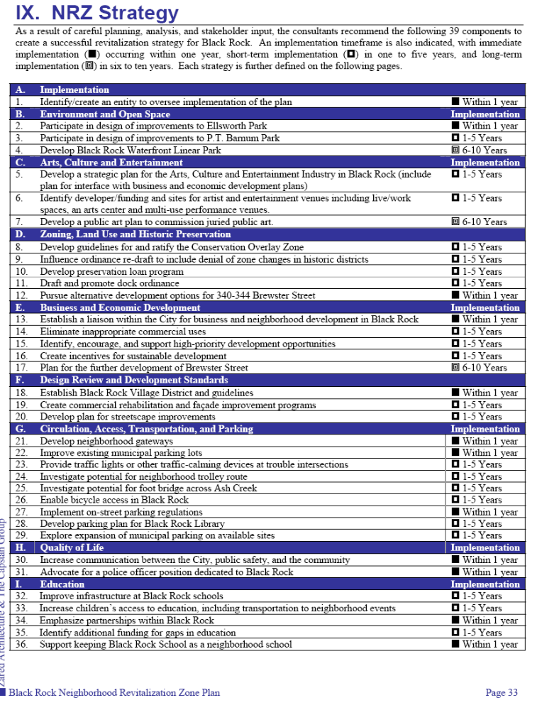

Appendix A (continued): Status of Strategic Plan Tasks

Table A-2: Detailed Status of each Strategic Plan Task

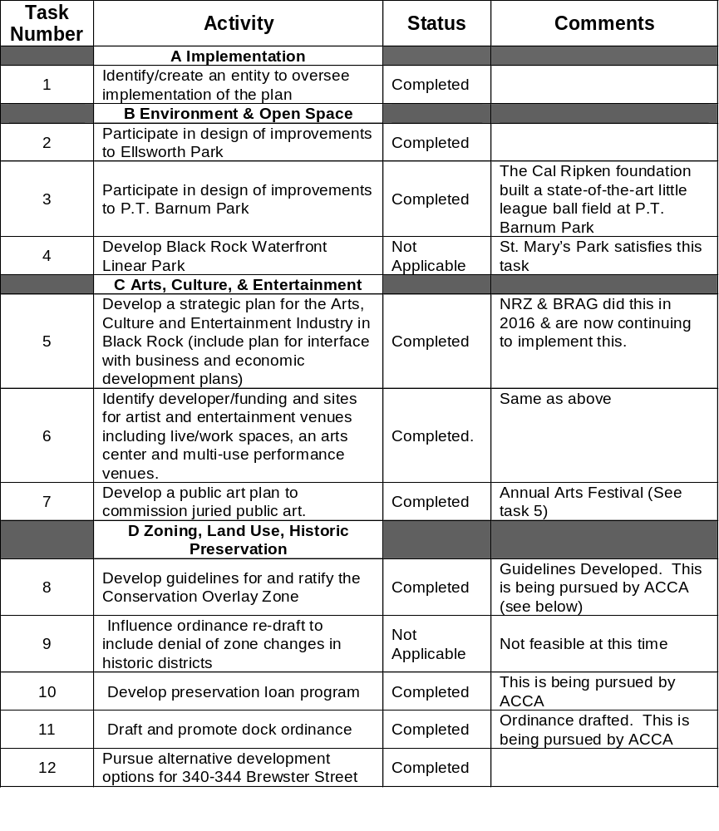

Appendix A (continued): Status of Strategic Plan Tasks

Table A-2 (continued): Detailed Status of each Strategic Plan Task
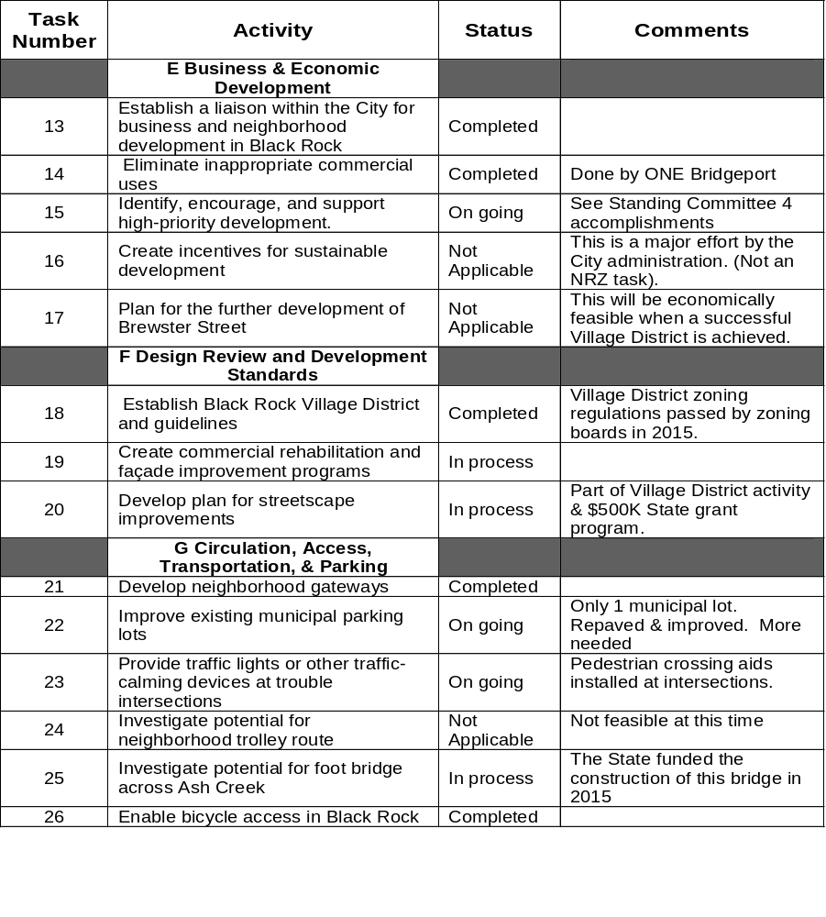

Appendix A (continued): Status of Strategic Plan Tasks

Table A-2 (continued): Detailed Status of each Strategic Plan Task

