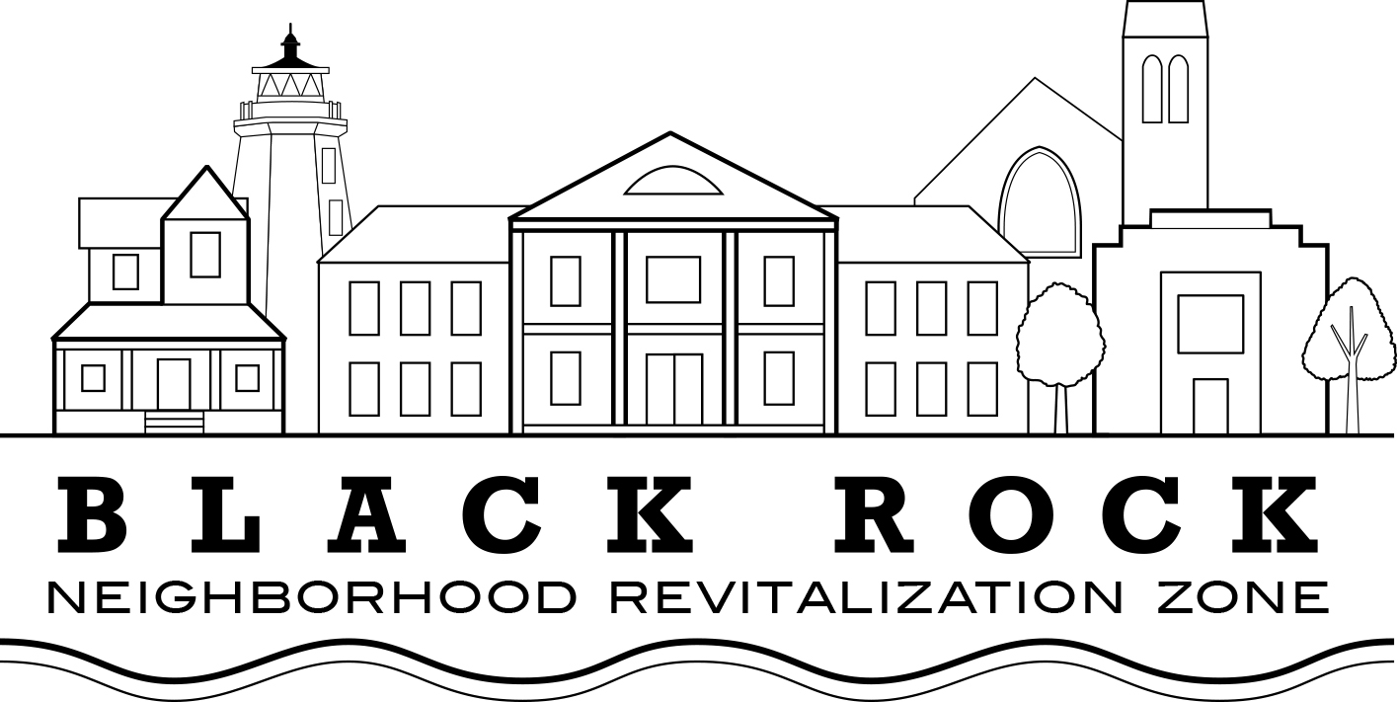

AGENDA FOR SEPTEMBER 26, 2017 BOARD OF DIRECTORS MEETING

Approval of Minutes (Joe – please email to Board ahead of meeting)

Old Business:

- Treasurers Report – John Marshall Lee

New Business

- NRZ Leadership Committee (Joe Ianniello)

- Standing Committee's Reports and Updates

  - Standing Committee 1: Business & Economic Development
  - Standing Committee 2: Education
  - Standing Committee 3: Arts, Entertainment, & Culture
  - Standing Committee 4: Zoning, Land Use, Development, & Historic Preservation
  - Standing Committee 5: Outreach & Communications
  - Standing Committee 6: Quality of Life, Environmental, & Public Safety

- Selection of Nominating Committee

- Election of New President

- Discussion Topics:
Environmental Task Foce (Stuart)
Website – thank you to Kate Spain
UI Tree Update via Laz – thank you, Laz!
How committees need to govern themselves
Update of Brewster Intersection, Fox Street Bridge
- Meeting open for Community Participation

