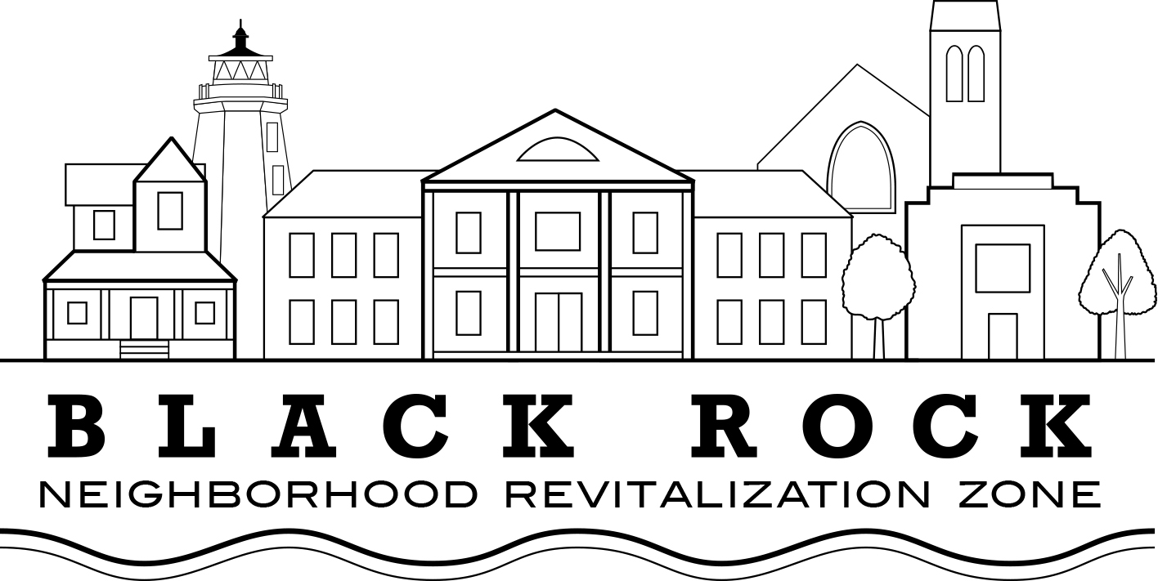

AGENDA FOR DECEMBER 12, 2016 BOARD OF DIRECTORS MEETING

GUEST SPEAKERS:

Representatives from United Illuminating will give a presentation on plans for tree work here in Black Rock and surrounding neighborhoods

Presentation by Kathy Dorgan, Resilient Bridgeport and David Kooris, State of Connecticut Department of Housing

Approval of Minutes

Old Business:

- Treasurers Report

New Business

- NRZ Leadership Committee

- Standing Committee's Reports and Updates

  - Standing Committee 1: Business & Economic Development
    - Status of Village District efforts

  - Standing Committee 2: Education

  - Standing Committee 3: Arts, Entertainment, & Culture

  - Standing Committee 4: Zoning, Land Use, Development, & Historic Preservation

  - Standing Committee 5: Outreach & Communications

  - Standing Committee 6: Quality of Life, Environmental, & Public Safety

- Election of 2 Directors for vacancies; Selection of Nominating Committee

- Discussion: The City of Bridgeport will no longer act as a fiduciary on NRZ projects. How should BR NRZ proceed?

- Meeting open for Community Participation

