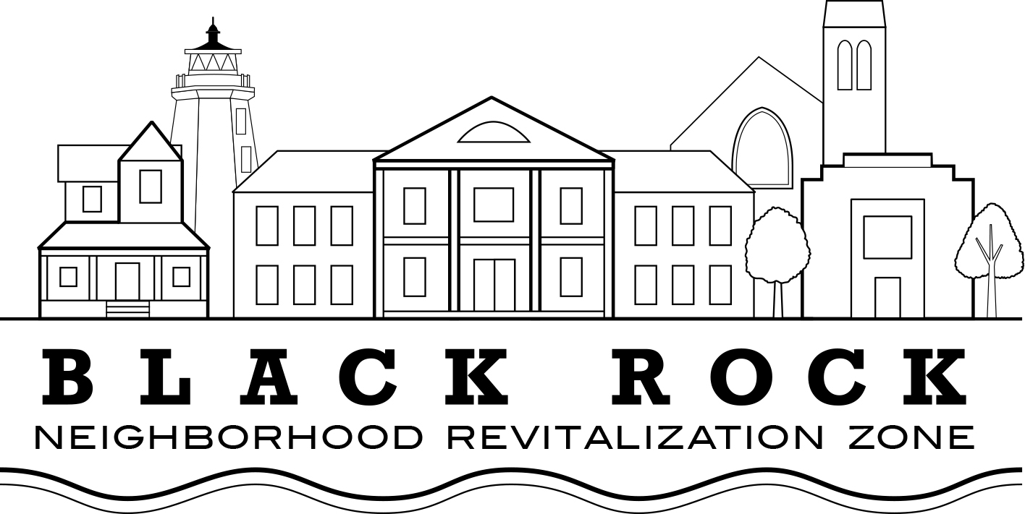
Regular Meeting Agenda
Wednesday, February 21, 2018

Approval of Minutes:
- Dec. 15, 2017

Old Business:

Treasurer’s Report – John Marshall Lee

NRZ Leadership Committee Report: Joe Ianniello

New Business

Standing Committee Reports

  - Standing Committee 1: Business & Economic Development
  - Standing Committee 2: Education
  - Standing Committee 3: Arts, Entertainment, & Culture
  - Standing Committee 4: Zoning, Land Use, Development, & Historic Preservation
  - Standing Committee 5: Outreach & Communications
  - Standing Committee 6: Quality of Life, Environmental, & Public Safety

Bylaws Change Proposals – Joe Ianniello

Quorum standard

Term Limits

Black Rock Farmer’s Market Update – Michelle Margo, Karyn Leito

VOD Updates: 2253 Fairfield Ave (Barnum Station Post Office building), Gateway Project (Fairfield Ave/Brewster), Ash Creek Pedestrian Bridge; Boys and Girls Village CDBG support – Scott Burns (to address what not covered by John Weldon)

Black Rock Community Council/Black Rock NRZ Coordinated Efforts: Business Outreach; 375th Anniversary Celebration – Phil Blagys

Elected officials’ reports: City Council, State Representative

Public input, questions

