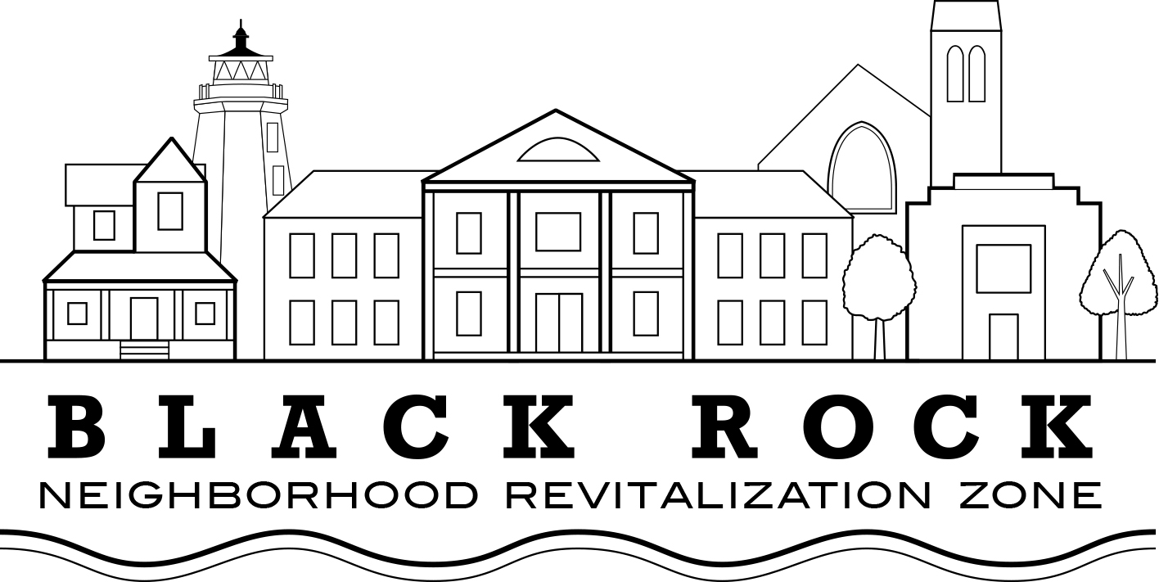
Annual Meeting Agenda
Thursday, June 20, 2019

Approval of Minutes:
- February 20, 2019

Old Business:

Treasurer’s Report: John Marshall Lee

NRZ Leadership Committee Report: Joe Ianniello

New Business

- Elections of new Board Members Calvin Jones, Peoples Bank, Bridgeport; reappointment of Daivd Barbour, Joe Ianniello, Michelle Margo, Karen Leito

- Elections of Executive Officers: President, Vice President, Secretary, Treasurer, two executive committee members, one ex oficio member (St. Rep. Steve Stafstrom); Nominating Committee: John Marshall Lee, John Soltis, Courtney Hartl, Michelle Margo

- Announcement of Dates of Regular Meetings through June 2020

- Strategic Plan Update

Standing Committee Reports

  - Standing Committee 1: Business & Economic Development
  - Standing Committee 2: Education
  - Standing Committee 3: Arts, Entertainment, & Culture
  - Standing Committee 4: Zoning, Land Use, Development, & Historic Preservation
  - Standing Committee 5: Outreach & Communications
  - Standing Committee 6: Quality of Life, Environmental, & Public Safety

Elected Officials’ Reports

  - City Council Representatives: Christina Smith, Pete Spain
  - State Representative Steve Stafstrom

Public Discussion

