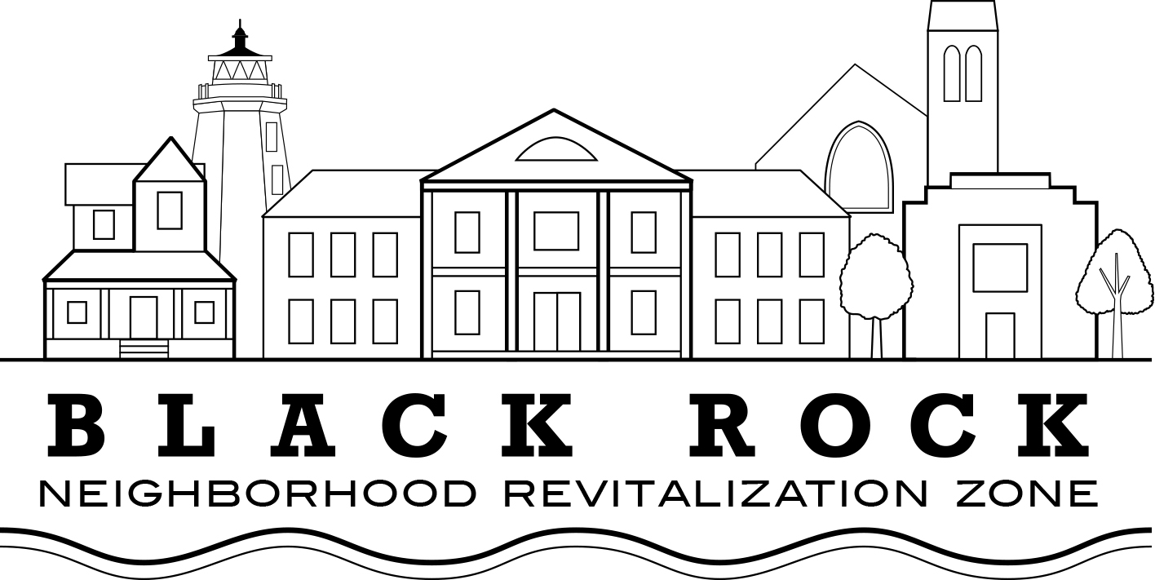
Special Meeting Agenda
Friday, December 15, 2017
(Revised)

The purpose of this meeting is to elect a president for the Black Rock NRZ

- Report from the Search Committee.
- Nominations and Voting as required
- Adjournment

