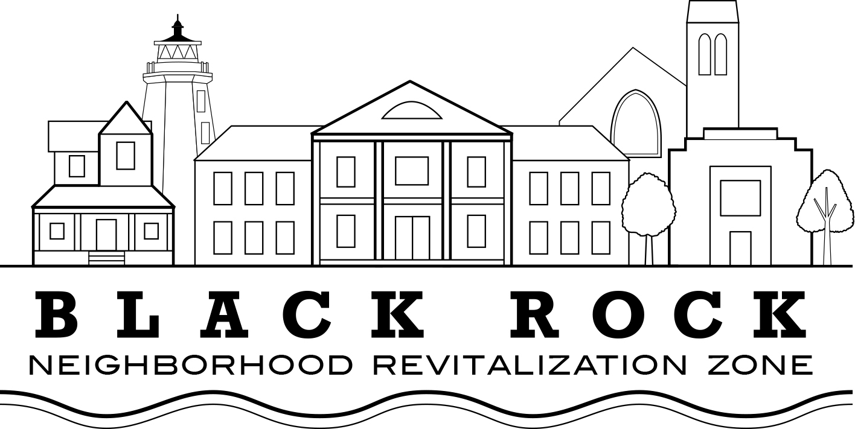
Regular Meeting Agenda
Wednesday, February 20, 2019
Gary Crooks Center, 301 Bostwick St, Bridgeport CT

Approval of Minutes:
- Nov. 29, 2018

Old Business:

Treasurer’s Report – John Marshall Lee

NRZ Leadership Committee Report: Joe Ianniello

New Business

I –Hosts’ Update: PT Residents (Vanessa Liles)

II -Streetscape Project: Rt. 130/Ash Creek Fairfield Ave entrance; Fairfield/Brewster St intersection
(Bill Coleman, Jacob Robison – City of Bridgeport OPED)

III -Environmental Task Force (ETF): PSEG funding and possible role for Black Rock NRZ to serve as fiduciary (Stuart Sachs)

IV - Strategic Plan Update (Council Rep Christina Smith)

V- Community Support
- CDBG Letters of Support: Gifted Hands Boxing Association; PT Partners/Park City Communities
- BR NRZ Donations: Burroughs (Taste of Black Rock); Black Rock 375; Aim Higher Together Bridgeport (Courtney Hartl)
VI – Land Use Committee: New policy proposal; possible merger with Design Committee
(David Barbour)

Standing Committee's Reports

  - Standing Committee 1: Business & Economic Development
  - Standing Committee 2: Education
  - Standing Committee 3: Arts, Entertainment, & Culture
  - Standing Committee 4: Zoning, Land Use, Development, & Historic Preservation
  - Standing Committee 5: Outreach & Communications
  - Standing Committee 6: Quality of Life, Environmental, & Public Safety

Elected Officials’ Reports

- Council Reps Pete Spain, Christina Smith
- State Rep. Steve Stafstrom

