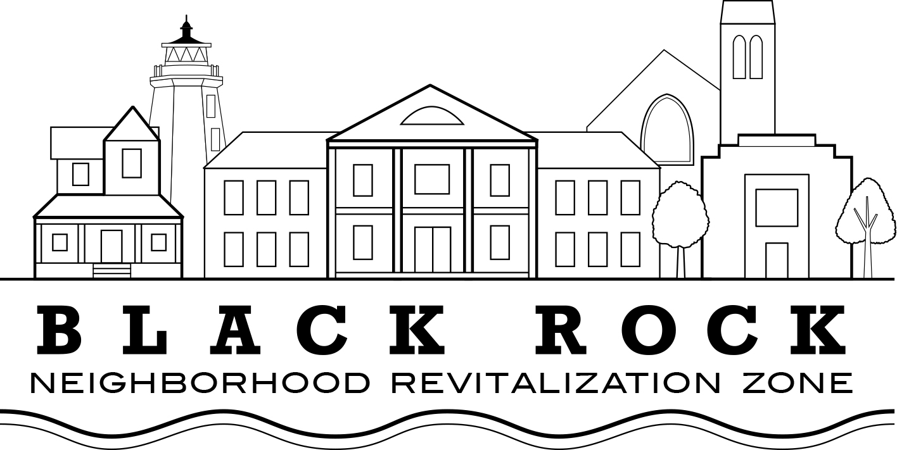
Regular Meeting Agenda
Wednesday, March 11, 2020

Approval of Minutes:
- January 16, 2020

Old Business:

Treasurers Report – John Marshall Lee

NRZ Leadership Committee Report: Joe Ianniello

New Business

Standing Committee's Reports

  - Standing Committee 1: Business & Economic Development
  - Standing Committee 2: Education
  - Standing Committee 3: Arts, Entertainment, & Culture
  - Standing Committee 4: Zoning, Land Use, Development, & Historic Preservation
  - Standing Committee 5: Outreach & Communications
  - Standing Committee 6: Quality of Life, Environmental, & Public Safety

Board Nominations: Jon Fatigate, Val Rossi

Board Approval: Donation to Burroughs Center, Taste of Black Rock

Presentation: Main Street America: Val Rossi

Presentation/Update: Communication/Outreach Update: Jon Fatigate

