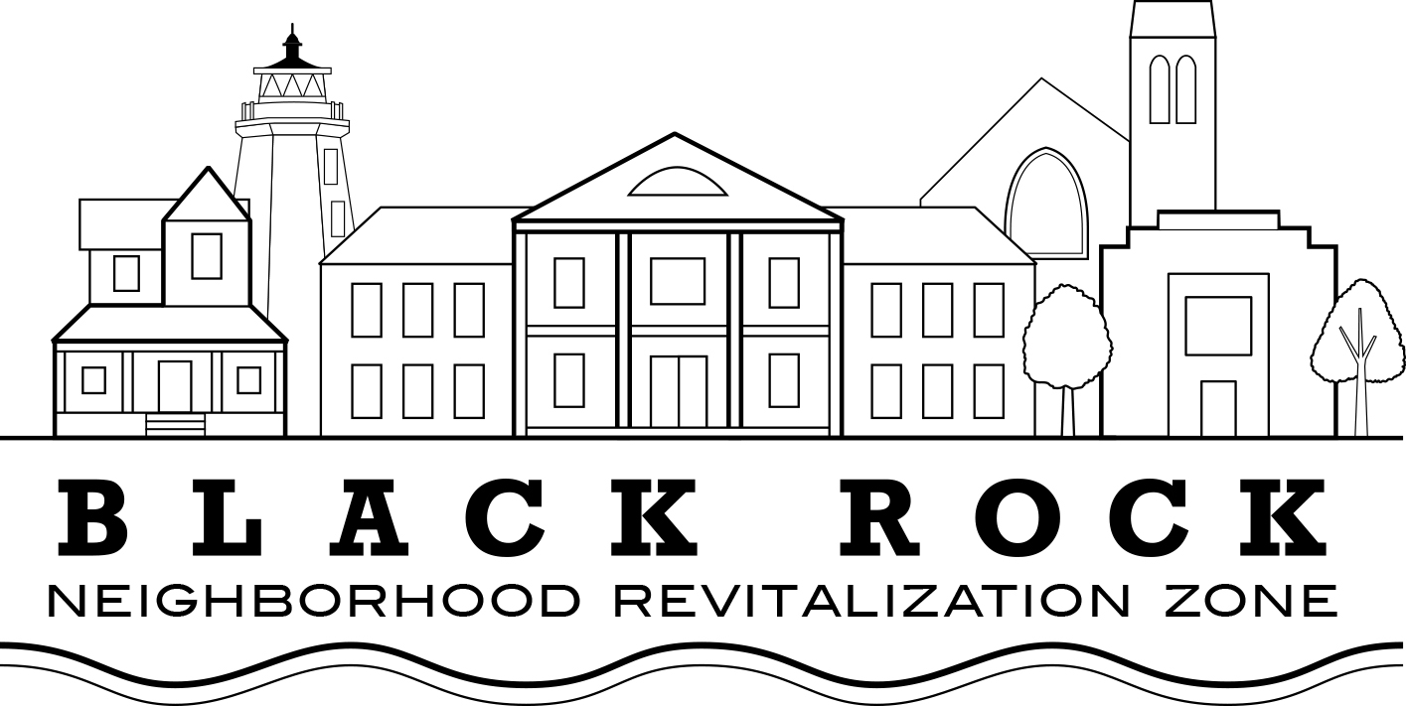

Regular Meeting Agenda
Wednesday, October 9, 2019
Hub & Spoke Restaurant
3001 Fairfield Ave,
Bridgeport CT

Approval of Minutes:
- Annual meeting, June 20, 2019
- Special Meeting July 6, 2019

Old Business:

Treasurer’s Report – John Marshall Lee

NRZ Leadership Committee Report: Joe Ianniello

New Business

I –Pollinators Partner Project – Mardi Morrow, Black Rock Garden Club

II – Land Use Committee: Showcase Cinema/Canfield Ave Eastpointe Project Update
(David Barbour)

III – Capital project requests

IV - Strategic Goals Revision Update (Scott Burns/Council Rep Christina Smith)

Standing Committee's Reports

  - Standing Committee 1: Business & Economic Development
  - Standing Committee 2: Education
  - Standing Committee 3: Arts, Entertainment, & Culture
  - Standing Committee 4: Zoning, Land Use, Development, & Historic Preservation
  - Standing Committee 5: Outreach & Communications
  - Standing Committee 6: Quality of Life, Environmental, & Public Safety

Elected Officials’ Reports

- Council Reps Pete Spain, Christina Smith
- State Rep. Steve Stafstrom

